

Canada Vapes Sales Growth and AOV Strategy

Final Report
Course Code: MGMT 6219
Name | Student ID
Absasiaka Anwanakak | 1208151
Gift Oyugi | 1349890
Damian Okelue | 1298980
Sahil Kamane | 1273968
Busayo Adebayo | 1233210

Institution: Fanshawe College
Date: August 05, 2026
Table of Contents
Final Report 1
EXECUTIVE SUMMARY 4
KPI’s Summary 4
Recommendation: 4
INTRODUCTION & BUSINESS CONTEXT 5
Business Challenge 5
Research Questions 5
Scope and Terminology 5
METHODOLOGY 6
Data Sources and Tools 6
Analytical Approach 6
Why These Methods Were Chosen 6
Ethics and Governance Embedded in the Method 6
LIMITATION 7
FINDINGS & ANALYSIS 7
Executive Sales Performance 7
Figure 1: Executive Sales Dashboard 7
Sales Growth and Three-Year Forecast 8
Figure 2: Historical Net Sales and Three-Year Forecast Dashboard 8
Customer Average and forecast AOV 8
Customer Behavior and Revenue Concentration 9
Figure 3: Customer Opportunity and Net Sales by Customer Type 9
Hypothesis for Controlled Testing 9
Regional AOV Growth Priorities 10
Figure 4: Regional AOV-Growth Priority Dashboard 10
Regional decision rule: 10
AOV Measurement and Target Interpretation 10
Figure 5: Regional Average Order Value Forecast Dashboard 11
AOV values after filter and denominator 11
Ethics, Privacy, Governance, and Responsible Marketing 11
Analytical privacy and regulatory compliance recommendation 12
RECOMMENDATION & NEXT STEPS 13
Strategic Recommendations 13
90-Day Action Plan 14
Expected Management Outcomes 14
Conclusion 14
APPENDICES 15
Appendix A: Metric Definition and Reconciliation 15
Figure 6: Python Validation of Actual and Forecast Net Sales 15
Appendix B: Data Quality and Analytical Limitations 16
Data Quality Controls for Future Refreshes 16
Appendix C: Python Workflow and Reproducibility 16
Reproducible Output Checks 17
Appendix D: Dashboard Rubric and Accessibility Checklist 17
Suggested Executive Dashboard Navigation 18
REFERENCES 19

EXECUTIVE SUMMARY
Canada Vapes has a solid sales position and a solid future to grow the business. Python validated 177,142 orders that were for positive values, 22,569 identifiable customers and $18,173,726 in completed net sales. There is a slight difference (AOV) between order level AOV of $102.59 and about $101.84 on the executive dashboard which should be reconciled before performance is evaluated against the target of $120.
Retention is the most positive indicator of growth. Repeat customers make up 57.2% of identifiable customers and 95.9% of completed net sales over the previous 12 months. The average sale price of returning customers is $112.96 versus $75.50 of new customers, a 49.6% premium. It helps to preserve loyal customers and boost conversion from first purchase to repeat purchase, instead of just acquisition or deep discounts.
Net sales grew from $1,970,079 in 2021 to $5,268,416 in 2025, a 27.9% compound annual growth rate, and the supplied forecast reaches $7,998,665 by 2028. The forecast is favourable, but it's not a regulation, price, or confidence interval forecast as the file does not include details on any of these items.

KPI’s Summary
Executive KPI | Validated result | Management interpretation
Completed net sales | $18,173,726 | Large revenue base supports segmentation and trend analysis.
Completed orders | 177,142 | Sufficient transaction history for stable descriptive KPIs.
Order-level AOV | $102.59 | Approximately $17.41 below the $120 target.
Repeat customers | 12,902 (57.2%) | Retention and second-purchase conversion are major levers.
Returning-customer order AOV | $112.96 | 49.6% above new-customer order AOV.
Forecast net sales, 2028 | $7,998,665 | Positive outlook; validate monthly against actual results.

Recommendation: Approve a 90-day program to normalize AOV definitions, then pilot second purchase and basket building campaigns against holdout groups and then scale those offers that drive incremental sales, but do not compromise privacy, age gating, and responsible promotion controls.

INTRODUCTION & BUSINESS CONTEXT
This capstone transforms sales and customer data into actionable growth decisions for Canada Vapes. This report includes details about the methods and limitations, the Power BI dashboard includes the executive view, and the presentation communicates the findings and recommendations.

Business Challenge
Canada Vapes must determine what new sales will be made, who and where the company will get them and how to get AOV to $120. Management should focus on more than just revenue growth, repeat sales, basket value, customer centricity and responsible regional opportunities.

Research Questions
- How have completed net sales, orders, and AOV changed from 2021 to 2025, and what direction does the supplied three-year forecast indicate?
- How do new and returning customers differ in order value, and which customer segments contribute the most historical revenue?
- Which regions should be scaled, piloted, selectively targeted, or monitored based on reach, AOV gap, and commercial difficulty?
- How should Canada Vapes reconcile different AOV calculations, so the dashboard and report communicate one consistent target?
- What privacy, fairness, governance, and responsible marketing controls should be applied before campaign recommendations are operationalized?

Scope and Terminology
This report filters out order level AOV, customer average AOV and regional AOV. Order AOV to AOV for completed orders by completed orders; Customer-average AOV to AOV per customer by total customers; regional AOV can be calculated by either completed order AOV or customer-average AOV within a region. The calculation grain always must be specified, as each measure asks a different question.
The transaction dataset supports sales, customer type, product text, coupon use, and time-series analysis but has no region field. Regional findings therefore come from the submitted Power BI dashboards and the earlier Data Preparation and Ethics report, not from one integrated source.

METHODOLOGY

Data Sources and Tools
- Cleaned transaction dataset: order date, order ID, customer ID, status, customer type, product text, items sold, coupons, revenue, and net sales.
- Three-year forecast dataset: monthly forecasted orders and forecasted net sales for 2026 to 2028.
- Regional customer level analysis and Power BI dashboards: provincial AOV, regional reach, priority tiers, customer mix, and addressable gap visuals.
- Python and pandas: validation, filtering, KPI calculation, segmentation, revenue concentration, annual summaries, and forecast checks.
- Power BI: executive KPIs, trends, customer segments, regional priorities, drill through analysis, and presentation visuals.

Analytical Approach
- Loaded 181,641 transaction rows and standardized dates and numeric fields.
- Kept completed purchase statuses with positive net sales, producing 177,142 valid orders; refunds, fraud, reshipments, processing records, and non-positive completed records were excluded from core KPIs.
- Calculated net sales, AOV, items per order, coupon rate, customer type, annual sales, and customer purchase frequency.
- Built rule based planning segments from frequency, monetary value, recency, AOV, and coupon use; these are descriptive, not predictive.
- Aggregated the monthly forecast into annual orders and net sales, then calculated implied order-level forecast AOV.
- Compared Python, Power BI, and the Data Preparation and Ethics report to identify metric differences, limitations, and governance needs.

Why These Methods Were Chosen
Descriptive and diagnostic methods were appropriate because the data can show what happened and where opportunities exist, but it lacks the cost, campaign exposure, experimental assignment, and complete regional linkage needed to prove causal profit impact. Segmentation supports targeting, while forecast validation supports planning rather than statistical certainty.

Ethics and Governance Embedded in the Method
The method protects confidential data, uses aggregated reporting where possible, preserves source files, documents transformations, and acknowledges bias and sample size limits. Recommendations must not target underage individuals or encourage irresponsible use. PIPEDA principles on purpose limitation, limited collection, accuracy, safeguards, and accountability provide the governance framework (Office of the Privacy Commissioner of Canada, 2025).

LIMITATION
One major limitation of this project is that the available datasets could not be fully connected. The transaction dataset did not include a region field, so the team could not directly link regional performance to individual orders, products, coupons, or customer types. The data also did not include product costs, campaign expenses, shipping fees, profit margins, or marketing exposure. Therefore, the analysis can identify possible revenue opportunities, but it cannot confirm actual profit or return on investment.
The product descriptions were also not fully consistent, and the project contained different AOV measures because they were calculated at different levels. In addition, the forecast file did not provide information about the forecasting method, confidence intervals, or accuracy measures. Customer segments were created from past purchasing behaviour, so they may not predict how customers will respond to future campaigns. Finally, age-eligibility information was not included in the analytical data, so all marketing recommendations would require proper age verification and compliance checks before implementation.

FINDINGS & ANALYSIS

Executive Sales Performance
The executive dashboard shows about $18 million in completed net sales, 178,000 orders, AOV near $102, 23,000 identifiable customers, and a 13% coupon order rate. Python results closely match: $18,173,726 in net sales, 177,142 orders, 22,569 customers, $102.59 AOV, 3.02 items per order, and a 13.0% coupon rate.
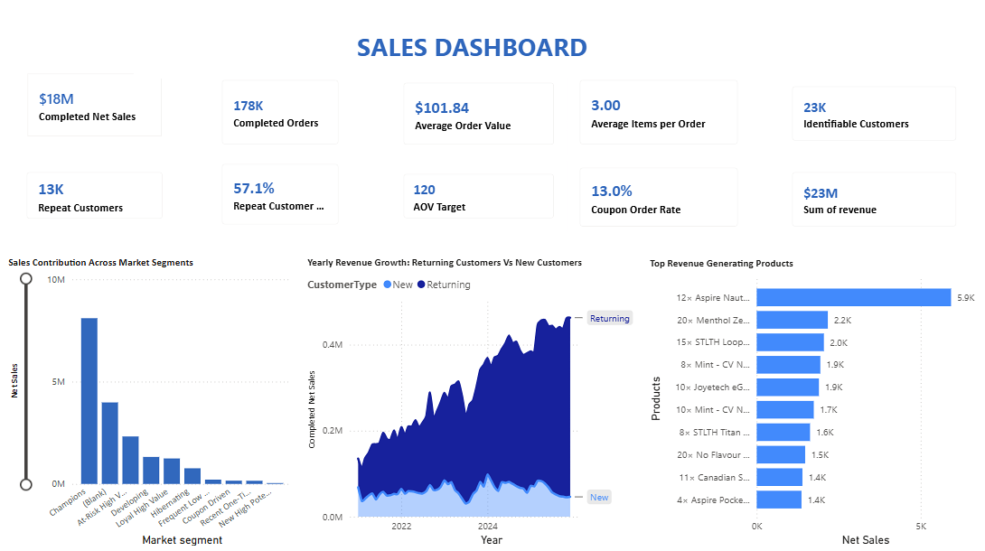

Figure 1: Executive Sales Dashboard
Together, the visuals show that champion, loyal, and returning customers form the strongest revenue base. Top products offer cross-sell ideas, but product text should first be standardized into governed product and category fields.
The rule based segmentation identified 3,707 champions who generated $13,655,454, or 75.1% of completed net sales. This is a useful test audience, not proof that every champion will respond to the same offer.

Sales Growth and Three-Year Forecast
Completed net sales rose from $1,970,079 in 2021 to $5,268,416 in 2025, a 27.9% compound annual growth rate. In 2025, sales grew faster than orders, showing that basket value also contributed.
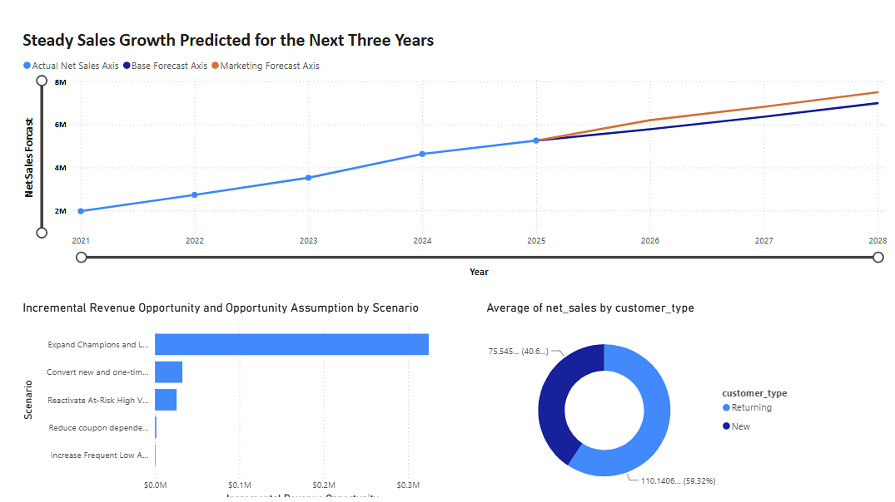

Figure 2: Historical Net Sales and Three-Year Forecast Dashboard

Customer Average and forecast AOV
Year | Type | Net sales | Orders | Implied order AOV
2021 | Actual | $1,970,079 | 22,093 | $89.17
2022 | Actual | $2,730,735 | 30,862 | $88.48
2023 | Actual | $3,535,304 | 33,443 | $105.71
2024 | Actual | $4,657,146 | 44,504 | $104.65
2025 | Actual | $5,268,416 | 46,119 | $114.24
2026 | Forecast | $6,166,513 | 52,169 | $118.20
2027 | Forecast | $7,082,589 | 58,438 | $121.20
2028 | Forecast | $7,998,665 | 64,709 | $123.61

Forecast AOV is derived as forecasted net sales divided by forecasted orders. It is not the same measure as the dashboard’s customer-average AOV forecast. The forecast increases from $6,166,513 in 2026 to $7,998,665 in 2028, a 14.9% annualized rate from the 2025 baseline. It should be monitored monthly against actual results because no forecast error measures are provided.

Customer Behavior and Revenue Concentration
The analysis identified 12,902 repeat customers, or 57.2% of identifiable customers. They generated 95.9% of completed net sales, and 16.9% of customers generated 80% of sales, showing both strong retention value and concentration risk.


Figure 3: Customer Opportunity and Net Sales by Customer Type
Returning customer orders average $112.96, versus $75.50 for new customers, a 49.6% difference. New customers therefore need simple second-purchase support, while returning customers are better suited to bundles, complementary products, loyalty benefits, and premium cross-sell.

Hypothesis for Controlled Testing
Customer priority | Evidence | Recommended treatment | Primary KPI
Champions / loyal | 75.1% of completed net sales from champion segment | Protect with early access, replenishment reminders, and service benefits | Retention rate and contribution margin
New / one-time | New-order AOV $75.50 | Trigger relevant second-purchase messages after the first order | First-to-second purchase conversion
Frequent low AOV | Repeated activity but lower basket value | Test bundles and minimum-spend thresholds | AOV lift and units per order
Coupon driven | Overall coupon order rate 13.0% | Reduce blanket discounts; test value-added incentives | Incremental margin and redemption quality

Regional AOV Growth Priorities
The regional dashboard ranks Ontario and Quebec for scale because of their reach and composite priority scores. Nova Scotia and British Columbia are pilot, or expansion markets, Alberta and New Brunswick are selective opportunities, and smaller high AOV regions should be monitored until volume supports firm conclusions.
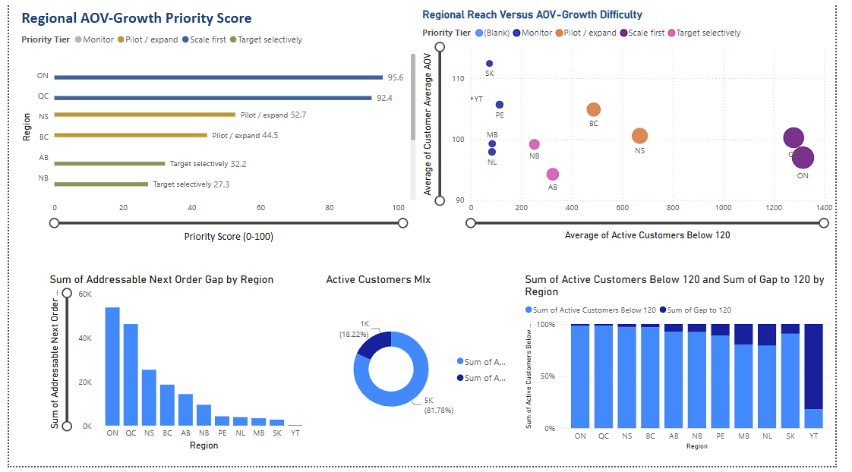

Figure 4: Regional AOV-Growth Priority Dashboard
The dashboard combines a priority score, reach-versus-difficulty bubble chart, addressable next-order gap, customer mix, and below target regional counts. The earlier Data Preparation and Ethics analysis ranked Nova Scotia highest on the historical equivalent gap to the $120 weighted AOV target because it was only slightly below target but had high order volume. The later dashboard ranks Ontario and Quebec highest after combining reach, AOV, and implementation difficulty which make the methods answer different questions.
A two-stage approach reconciles the findings: test bundles, thresholds, and messages in Nova Scotia and British Columbia, then scale successful tactics in Ontario and Quebec.
Regional decision rule: Pilot where learning is affordable; scale where reach is large; monitor where averages are strong, but customer volume is small.

AOV Measurement and Target Interpretation
AOV is the main growth KPI, but valid values differ by grain: $101.84 on the executive dashboard, $102.59 from completed order Python validation, $101.62 on the regional dashboard, and $100.50 mean customer AOV with an $84.73 median. The lower median shows that high value customers lift the average.
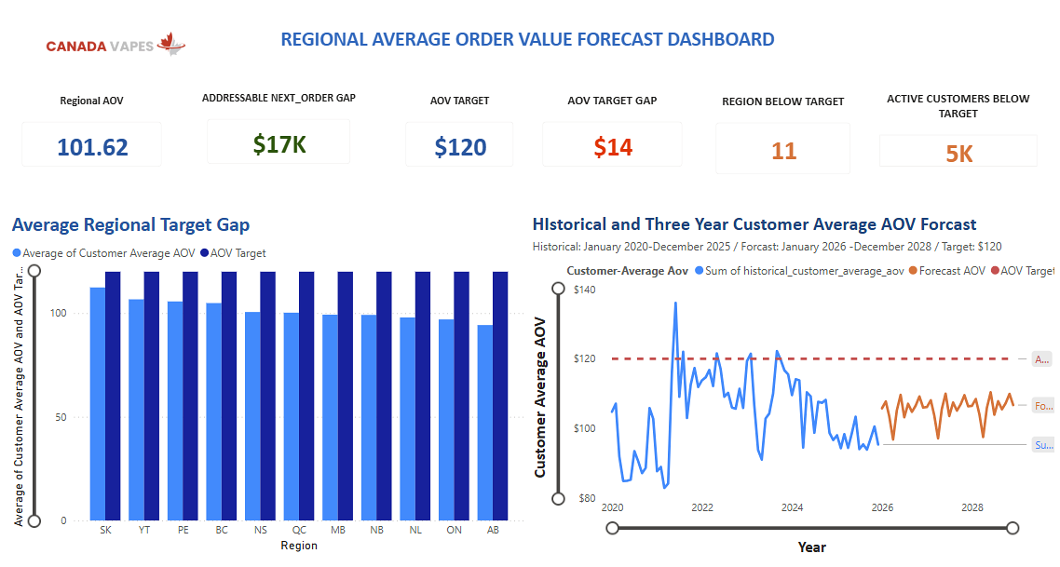

Figure 5: Regional Average Order Value Forecast Dashboard

AOV values after filter and denominator
AOV measure | Value | Calculation grain | What it answers
Weighted completed-order AOV | $102.59 | Net sales ÷ completed orders | Average value of a completed order
Executive dashboard AOV | $101.84 | Power BI filter context | Executive view; requires measure reconciliation
Regional dashboard AOV | $101.62 | Average across regional/customer measures | Regional comparison and target gap
Mean customer AOV | $100.50 | Average of customer-level AOV values | Typical customer-average behaviour
Median customer AOV | $84.73 | Middle customer-level AOV | Less sensitive to high-value outliers

The forecast implies order level AOV of $118.20 in 2026, $121.20 in 2027, and $123.61 in 2028, while the regional customer average forecast remains below $120. These are different measures, not competing forecasts. Canada Vapes should decide whether the target applies to order AOV, customer average AOV, or both, then use separate target lines and variance measures.

Ethics, Privacy, Governance, and Responsible Marketing
Because vaping is regulated, the analysis requires strong responsible use controls. Customer level data remains confidential without names, so access should be restricted, results aggregated, transformations documented, and recommendations kept away from underage or irresponsible use.
PIPEDA supports purpose limitation, consent, limited collection and use, accuracy, safeguards, openness, and accountability. Canada Vapes should use only data needed for approved retention and AOV work, protect privacy-safe identifiers, document eligibility rules, and avoid inferred sensitive traits. Health Canada also requires effective restriction of online promotions from young persons; self-declaration alone is not sufficient age verification (Health Canada, 2020).

Analytical privacy and regulatory compliance recommendation
Ethics / governance risk | Why it matters in this project | Required control before activation
Youth exposure | AOV and retention campaigns could become personalized promotion | Apply effective age and identity verification; exclude ineligible audiences; compliance review of creative and channels
Purpose creep | Customer data collected for transactions could be reused too broadly | Document the approved analytical purpose, fields used, retention period, and authorized users
Regional bias | Large provinces may dominate because of existing scale; small regions may show unstable averages | Report sample size and reach with AOV; avoid conclusions based on AOV alone
Privacy and confidentiality | Pseudonymous purchase history can remain sensitive and linkable | Restrict access, use secure storage, aggregate reporting, and maintain an access and version log
Misleading ROI claims | Revenue opportunity is not profit and descriptive lift is not causation | Use holdout groups and add cost/margin data before budget scaling
Data integrity | Different AOV definitions can lead to conflicting decisions | Govern metric definitions, data lineage, refresh timing, and validation tests

Revenue growth is not successful if it breaches age-gating, exceeds the approved data purpose, or creates an unmeasured margin loss. Responsible analytics keeps decisions transparent, testable, and auditable.

RECOMMENDATION & NEXT STEPS

Strategic Recommendations
The evidence supports a staged growth model: protect the existing revenue base, convert new customers earlier, raise basket value, and scale regional activity only after measures and campaign lift are validated.
- Establish one governed AOV and growth scorecard before activation.
Approve a metric dictionary for weighted order AOV, customer average AOV, regional AOV, target gap, repeat rate, and incremental lift. Reconcile Power BI and forecast measures to these definitions, review forecast versus actual monthly, and do not scale campaigns while material KPI differences remain unexplained.
- Defend the core revenue base while reducing concentration risk.
Champions contribute 75.1% of completed net sales and repeat customers 95.9%, creating both growth potential and concentration risk. Use replenishment reminders, early access, relevant bundles, and service benefits for eligible adults, while tracking retention, contribution margin, inactivity, and top customer revenue share. Avoid greater dependence on blanket discounts or a small buyer group.
- Build a measurable first-to-second purchase engine.
New customer orders average $75.50 versus $112.96 for returning customers, making second purchase conversion a priority. Test product relevant follow-ups, replenishment timing, complementary recommendations, and service incentives within 30-, 60-, or 90-day windows. Measure incremental conversion, repeat rate, AOV, opt-outs, and contribution margin against a holdout group.
- Close the AOV gap through basket design and a pilot-then-scale regional model.
AOV is about $17 below the $120 target, with roughly 3.0 items per order and a 13% coupon rate. Test complementary bundles, premium alternatives, and minimum spend thresholds instead of broad couponing. Pilot in Nova Scotia and British Columbia, scale proven tactics in Ontario and Quebec, target Alberta and New Brunswick selectively, and monitor small high AOV regions until sample sizes are reliable.
- Convert the forecast into a profit-based operating plan.
The forecast reaches about $8.0 million by 2028 and implies order AOV above $120 from 2027, while the regional customer average forecast stays below target. Treat this as a planning signal, not a guarantee. Add product cost, discounts, shipping and payment costs, campaign exposure, experiment assignment, consent status, and age eligibility; scale only when incremental contribution, forecast variance, privacy, and responsible-marketing standards are acceptable.

90-Day Action Plan
Timing | Focus | Actions | Success measures / decision gate
Days 1-15 | Metric and data governance | Approve AOV definitions; reconcile dashboard measures; document lineage, filters, and refresh rules; confirm privacy and compliance ownership | One signed metric dictionary; no unexplained KPI differences
Days 16-45 | Pilot design | Build adult-eligible holdout and treatment groups; design second purchase and bundle tests in NS/BC; add margin estimates where possible | Valid experiment design; baseline balance; approved creative and eligibility rules
Days 46-75 | Campaign execution | Run controlled tests; monitor AOV, order rate, conversion, margin proxy, opt-outs, and data-quality exceptions | Positive incremental lift without compliance or data-quality issues
Days 76-90 | Scale decision | Compare test and holdout outcomes; update forecast; scale only proven mechanics to ON/QC; document lessons learned | Approved scale/no-scale decision based on incremental results

Expected Management Outcomes
- A single governed AOV and growth scorecard that reconciles Power BI, Python, and the forecast.
- Lower revenue-concentration risk through retention and first-to-second purchase conversion.
- Higher basket value from tested bundles and thresholds rather than increased dependence on blanket couponing.
- Regional investment decisions based on both reach and verified incremental lift before ON/QC scale-up.
- Profit-aware, privacy-safe, age-eligible campaign execution with an audit trail.

Conclusion
Canada Vapes has a value-capture opportunity, not a demand problem. Sales grew at a 27.9% compound annual rate and the forecast approaches $8.0 million by 2028, but 75.1% of completed net sales comes from champions, 95.9% from repeat customers, and AOV remains below $120 under several measures. The company should protect high-value customers, improve first-to-second purchase conversion, raise basket value, and scale regional tactics only after four gates are met: reconciled AOV definitions, positive holdout-tested lift, acceptable contribution margin, and verified privacy and age eligibility.

APPENDICES

Appendix A: Metric Definition and Reconciliation
This appendix defines the calculation rules to use consistently in Power BI, Python, and the presentation. Each metric name must state its analytical grain.
Metric | Recommended definition | Primary use | Common risk
Completed net sales | Sum of net sales for approved completed statuses with net sales > 0 | Revenue performance and forecast base | Including refunds, fraud, reshipments, or non-positive records
Completed orders | Distinct completed order-id values after the same status and value filters | Order volume and AOV denominator | Using row count when orders can repeat
Weighted order AOV | Completed net sales ÷ completed orders | Commercial basket value | Confusing it with average customer AOV
Customer-average AOV | Average of each customer’s order-level AOV | Customer behaviour and segmentation | Allowing one-order customers and high-value outliers to change interpretation
Repeat customer rate | Customers with more than one completed order ÷ identifiable customers | Retention base | Using customer type labels instead of observed completed-order history
Addressable AOV gap | Eligible below-target population × defined target gap, with time window and grain stated | Scenario sizing | Presenting historical equivalent as forecast or profit
Incremental lift | Treatment outcome minus comparable holdout outcome | Campaign effectiveness | Attributing all post-campaign sales to the campaign

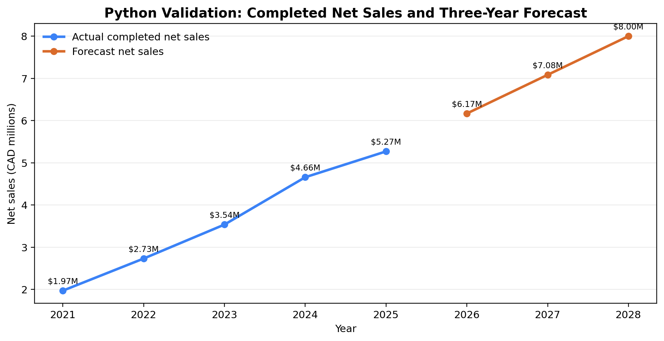

Figure 6: Python Validation of Actual and Forecast Net Sales

Appendix B: Data Quality and Analytical Limitations
Limitation | Analytical impact | Required next step
Transaction file has no region field | Regional results cannot be independently rebuilt from the transaction dataset | Create a governed customer-to-region or order-to-region key and document join quality
Forecast file lacks model metadata | No confidence interval, error measure, or scenario assumptions are available | Document forecast method; track monthly MAPE or comparable error measure
No product cost or campaign cost | Revenue opportunity cannot be translated into contribution profit or ROI | Add cost, margin, discount, shipping, payment fee, and marketing spend fields
Product descriptions are text strings | Top-product and bundle analysis can be affected by inconsistent names and quantities | Create governed SKU, category, brand, and product family fields
Multiple AOV definitions | Dashboard and report can appear inconsistent even when each measure is mathematically valid | Approve a metric dictionary and enforce measure names in all deliverables
Historical customer segmentation | Segments describe past behaviour and may not predict response | Test segment treatments with holdout groups and refresh rules
Age eligibility not  present in analytical file | Campaign lists cannot be assumed to be legally eligible for vaping promotion | Perform age/identity eligibility checks in the activation system, not in the reporting dataset

Data Quality Controls for Future Refreshes
- Schema tests: required columns and data types must be present before refresh.
- Domain tests: valid status codes, positive completed sales, non-negative items, and accepted date ranges.
- Identity tests: order IDs unique at order grain; privacy-safe customer ID coverage monitored.
- Metric tests: AOV recalculates within an approved tolerance; dashboard cards reconcile to Python totals.
- Freshness tests: extract timestamp, reporting window, and refresh service level recorded.
- Distribution tests: median, p95/p99, coupon rate, customer mix, and regional mix monitored for unexpected shifts.
- Governance tests: access, purpose, retention, age-eligibility handoff, and campaign audit trail documented.

Appendix C: Python Workflow and Reproducibility
The Python workflow loads the final files, applies the completed sales filter, calculates KPIs and customer features, and exports summaries. The excerpt below shows the core logic.
completed_statuses = ["Completed", "Curbside-Complete", "Home-Delivery-Com"]
purchases = df.loc[
df["status"].isin(completed_statuses)
& df["net_sales"].gt(0)
& df["order_id"].notna()
& df["date"].notna()
].copy()
completed_net_sales = purchases["net_sales"].sum()
completed_orders = purchases["order_id"].nunique()
weighted_aov = completed_net_sales / completed_orders
orders_per_customer = purchases.groupby("customer_id")["order_id"].nunique()
repeat_customer_rate = orders_per_customer.gt(1).mean()

Reproducible Output Checks
These values provide an audit trail across the dataset, Python code, dashboard, and report.
Check | Validated output
Raw transaction rows | 181,641
Completed positive-value orders | 177,142
Completed net sales | $18,173,726.47
Weighted order AOV | $102.59
Identifiable customers | 22,569
Repeat customer rate | 57.2%
Returning order AOV | $112.96
New order AOV | $75.50
2021-2025 sales CAGR | 27.9%
2028 forecast net sales | $7,998,665

Appendix D: Dashboard Rubric and Accessibility Checklist
Assignment expectation | Current evidence | Final improvement
4-6 executive KPIs | Sales and regional dashboards contain the required KPI coverage | Limit the executive landing page to the most decision-relevant six; place supporting KPIs on detail pages
8-12 visualizations | Sales, customer, forecast, product, regional, and AOV visuals are present across dashboard pages | Remove redundant visuals and ensure each chart answers a distinct business question
Interactivity | Dashboard structure supports filterable analysis | Add slicers for date, region, customer type, segment, coupon use, and product group; add region and segment drill-through
Analytical DAX | Completed sales, orders, AOV, repeat rate, target gap, and opportunity measures are represented | Add explicit measure descriptions, filter context, and validation against Python outputs
Trend indicators | Historical and forecast lines are present | Add forecast variance, target variance, and direction icons with accessible labels
Accessibility | Blue/orange palette generally provides clear contrast | Add alt text, keyboard order, meaningful titles, non-colour cues, larger labels, and consistent number formatting
Story integration | Dashboard findings align with the report’s growth, retention, and regional themes | Use the same KPI names, target definitions, and recommendations in slides and report

Suggested Executive Dashboard Navigation
- Page 1 - Executive overview: completed net sales, orders, weighted AOV, repeat rate, target gap, and forecast variance.
- Page 2 - Customer growth: new versus returning, segment contribution, second-purchase funnel, coupon dependence, and top products.
- Page 3 - Regional opportunity: priority score, reach-versus-difficulty, regional AOV, addressable gap, and drill-through detail.
- Page 4 - Data and ethics: metric definitions, data freshness, exclusions, privacy notes, age-eligibility reminder, and forecast limitations.

REFERENCES
Canada Vapes. (2026a). Cleaned sales data with identifiers [Unpublished internal data set].
Canada Vapes. (2026b). Three-year sales forecast [Unpublished internal forecast data set].
Health Canada. (2020). Vaping products promotion regulations: Information sheet. https://www.canada.ca/en/health-canada/services/smoking-tobacco/vaping/product-safety-regulation/vaping-products-promotion-regulations-information-sheet.html
International Organization for Standardization. (2008). Software engineering—Software product quality requirements and evaluation (SQuaRE)—Data quality model (ISO/IEC Standard No. 25012:2008). https://www.iso.org/standard/35736.html
Microsoft. (n.d.). Power BI documentation. https://learn.microsoft.com/power-bi/
Office of the Privacy Commissioner of Canada. (2025). PIPEDA fair information principles. https://www.priv.gc.ca/en/privacy-topics/privacy-laws-in-canada/the-personal-information-protection-and-electronic-documents-act-pipeda/p_principle/
The pandas development team. (n.d.). pandas documentation. https://pandas.pydata.org/docs/
Python Software Foundation. (n.d.). Python documentation. https://docs.python.org/3/

